COMPUTER SCIENCE 378: INTRODUCTION TO DATABASE MANAGEMENT
Assignment 1
Total: 100 marks
Weight: 10% of your final grade
Due: After you have completed Unit 3.
Answer all of the following questions, and upload your completed work here.

Question 1 (15 marks)
Answer the following questions (250 words max/question).
- Explain the concept of program-data independence, and explain how it is achieved in the database
approach.
This is the separation of quantitative data from its characteristics (AKA Metadata). If we know that a needs to store sales records including the products and descriptions. We can separate these descriptions into a separate table. A table of sales records including a key to a produce. Wherein the product table can provide further details about weight, prices, colour etc.
This approach reduces storing the same value multiple times. Saving space and improving speed of the database. We don’t need to store a product weight 10 times. Just once, and look it up.
- Briefly contrast and compare the following development approaches: the systems development life cycle and the prototyping methodology.
The Systems Development Life Cycle SDLC approach is a more methodical approach. Each step in the development of a databases scheme is methodically designed and reviewed for completeness. The approach favors a long development time with the result being a complete working database. This approach would lend itself better to creating a new database from scratch where there is no restraints from pre-existing data.
The alternative, Prototyping methodology, appears better as an iterative process that quickly responds to issues by making small tweaks in existing scheme and information pathways. This approach would lend itself better to the evolution of a database that needs to support new features or new information pathways.
With virtual machines, prototyping methodologic and a more “evolutionary” approach is the more industry approach. As developers we can quickly test proposed changes with temporary databases spun up and cloned in seconds. However the traditional SDLC would still be the preferred approach to a new database, as the methodical process can assure success from the start.

- Discuss the difference between entity type and entity instance.
An Entity type would be the over arching type of object. Is it an employee or a product or a sales invoice. It is the manifest of parameters that determine what constitutes this entity. Meanwhile the entity instance would be a single instance of such an entity type. I have written an example below. The Entity type would be PRODUCT since it determines what type of products we are looking at. For this case products that a vendor would sell. Then below we have 3 product instances, each product can have different attributes however fit in the overarching type of vendor products.
Entity type: PRODUCT
ProductID (key) | ProductName(String) | Price (Int) | Description (STRING)
00572 | Pencil | 1.20 | A graphite pencil for writing
00234 | Pen | 0.86 | A permanent pen for writing
00112 | Eraser | 2.22 | Erases a pencil

Question 2 (15 marks)
Give a simple example of an E-R diagram for each of the following concepts:
- Associative entity
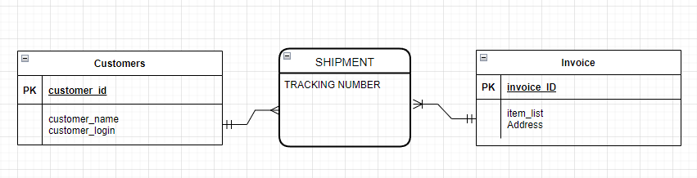
- Weak entity
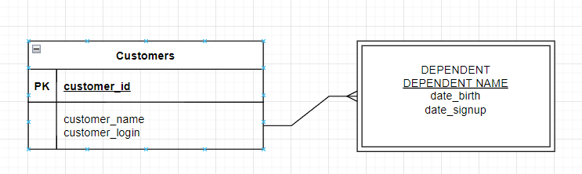
- Unary relationship
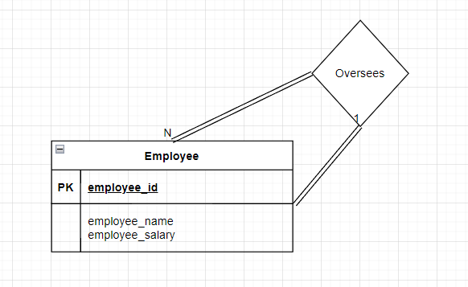

Question 3 (20 marks)
As an independent consultant, you have a contract with Athabasca University to develop an application to support course administration. Read the following detailed description of this application, and complete the tasks listed below.
- A course has a unique course number and title, and is assigned to one or more areas of the Computer Science program. Each course has an instructor, at least one teaching or research assistant, an online conference whiteboard, a time (interval), and a capacity (maximum number of participants). A course need not be offered each term, but the challenge option is open throughout the entire year. A course may have some prerequisite courses, and a student is not allowed to register for a course if s/he has not fulfilled the prerequisites or their equivalent. In addition, a student who would like to challenge a course should have the course prerequisites or authorization from the course instructor.
- An instructor has a first name, last name, email address, phone number, fax number, and is assigned to several areas of expertise. Note that two different instructors might have the same (first and last) names, and they might share the same fax number.
- A student is given a unique student number. For each student, we want to record first name and last name, email address, phone number, postal address, and GPA. Again, the same names may belong to two different individuals. A student may be enrolled in several courses each term. For each enrolment, we want to record the grade. There are two types of student: graduate and undergraduate. Undergraduate students have a study major, while graduate students have both a specialization and a thesis topic.
- A teaching assistant is a graduate student, and we need to record his/her first name, last name, year, and GPA, as well as how many courses (including the current one) the teaching assistant has already taught.
- A research assistant is a student for whom we want to record the usual basic information, plus the number of years of work experience. The research assistant provides laboratory support for students, manages the conference whiteboard, and does some programming tasks.
- An area of study is described by its name. An area may be divided into several sub-areas. These areas are used to categorize instructors, as well as courses. For example, the area of game development consists of sub-areas such as Graphics, Networking, and Human-Computer Interaction; the area of E-Services Technology consists of Artificial Intelligence, Networking, and Distributed Systems.
Hint: For each relation without a unique attribute or combination of attributes, introducing an artificial primary key
might be a good idea.
Design an ER diagram for this course administration system. Draw the complete ER diagrams, including all aspects discussed in the course. Clearly state any further assumptions made, but note that you must not override the specifications above.
Assumptions made:
- Instructor are assigned a unique id.
- Each student given by studentID, can be both undergraduate and graduate student types. We simply check for grad_specialization or grad_thesis NULL to determine undergraduate students.
- Challenge option will need to target a specific CourseID.
- A course must have 1 instructor, may have 1 RA, and may have many TA
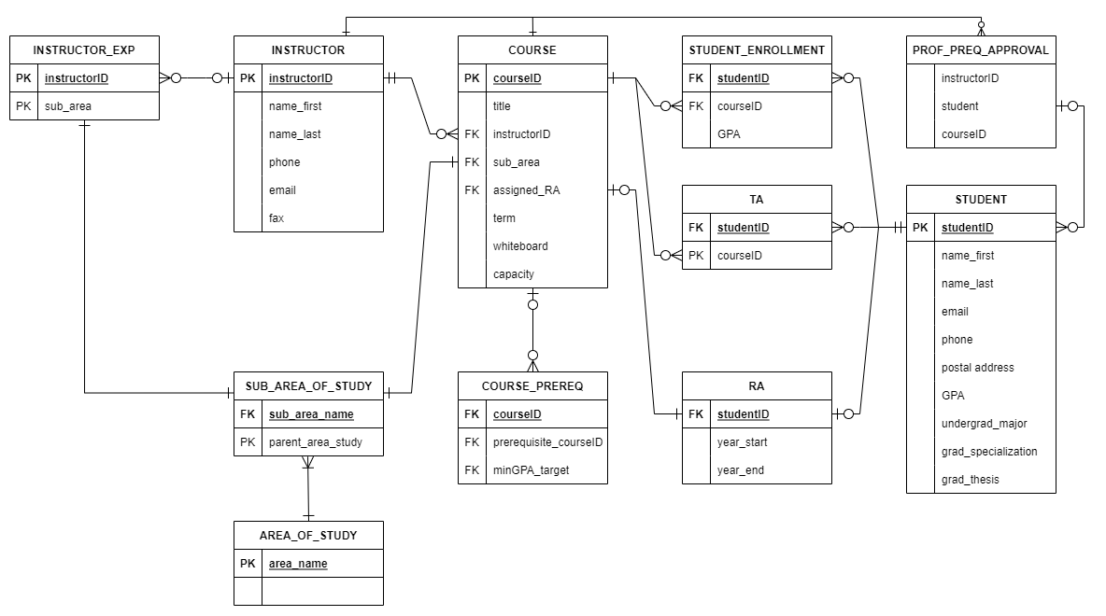

Question 4 (15 marks)
For each of the following relations, identify the Normal Form(s) each relation satisfies, and transform it into 3NF.
- Consider the relation STUDENT, where a student can have only one major:
RELATION = STUDENT (StuID, StuName, Major), Primary Key = {StuID}.
STUDENT
StuID | StuName | Major
This data set is already normalized since StuID, StuName, and Major variables are dependent on the primary key StuID.
- Consider the relation EMPLOYEE, where an employee can have more than one specialization:
RELATION = EMPLOYEE (EmpID, Name, Specialization), Primary Key = {EmpID}.
EMPLOYEE_NAME
EmpID | Name
EMPLOYEE_ Specialization
EmpID | Specialization
In this case an EmpID can be linked to multiple specializations so we create a new table to list all the specializations of that employee.
- Consider the relation LEASE, where a person can live in only one building, and a building can charge only one rental rate:
RELATION = LEASE (PersonID, BuildingID, Rent), Primary Key – {PersonID}.
PERSON
PersonID | BuildingID
BUILDING
BuildingID | Rent

Question 5 (20 marks)
Consider a one-relation database with the following attributes:
Employee number (emp_no), Date hired (date), Job title (job), Phone number (phone_no), Office number (office_no), Area (area), Salary (sal), project number (proj_no), Project budget (p_budget), Department number (dep_no), Department budget (d_budget), and Department manager employee number (mgr_emp_no).
The following business rules apply:
- No employee can manage more than one department at a time.
- No employee can work in more than one department at a time.
- No employee can work on more than one project at a time.
- No employee can have more than one office at a time.
- No employee can have more than one phone at a time.
- No employee can have more than one job at a time.
- No project can be assigned to more than one department at a time.
- No office can be assigned to more than one department at a time.
- Department numbers, employee numbers, project numbers, office numbers, and phone numbers are all “globally” unique.
The following functional dependencies also apply:
- emp_no → phone, emp_no → office_no, emp_no → dep_no, emp_no → proj_no
- {emp_no, date} → job, {emp_no, date} → sal
- phone_no → office_no, office_no → area, office_no → dep_no
- proj_no → dep_no, proj_no → p_budget
- dep_no → mgr_emp_no, dep_no → d_budget
- mgr_emp_no → dep_no
Transform this relation into 3 NF. Justify any decomposition.
- Start by listing the unique keys and the dependencies above.
- We know that a project can only exist inside a department so no need to list that twice.
- To keep so an employee can only manage one or less departments. We separate a new list of unique department managers and their departments.
EMPLOYEE
emp_no | phone_no | office_no | proj_no | job | date | sal
PROJECT
proj_no | p_budget | dep_no
OFFICE_NUMBERS
office_no | area | dep_no
DEPARTMENT
dep_no | d_budget
DEPARTMENT_MANAGERS
mgr_emp_no | dep_no
PHONE_NUMBERS
phone_no | office_no

Question 6 (15 marks)
Consider the following relations:
Emp(E_id: integer, E_name: string, Age: integer, Salary: real)
Works(E_id: integer, Dep_id: integer, affectation: date)
Dept(Dep_id: integer, Dep_name: string, budget: real, Manager_id: integer)
- What referential integrity constraints exist between these relations?
Referential integrity requires that a foreign key must have a matching primary key or it must be null. For the given data I can see the following keys will need to be enforced: Dep_id, E_id. If either key is changed, its relationship must also be changed to maintain the links.
- What are the options for enforcing these constraints when a user attempts to delete a Dept tuple?
When performing a delete request for the Dept table. We must change all instance of Works() that have this link. The existing links must be re-routed to an existing tuple or set to NULL. Many database systems can perform this check and return an error if the tables have been established properly.

